  Politeknik Negeri Bandung | Bahasa Inggris 2
 | Lecturer: Dra. Siti Yuliah, M.Pd.  Intan Sinta Dewi Rahayu, M.Pd.  Mira Nissa Murti, M.Pd.  Setya Resmini, M.Pd. | Skill Focus: Reading
 | Duration: 4x50’ | Topic 4: Making Inferences
Equipment: | White board, board marker, handout, projector, screen, laptop
Objectives: | After completing this lesson, you will be able to:  - explain the definition of inference  - explain the importance of making inferences in reading activity  - explain strategies of making inference  - making inferences from the text in general and academic contexts (missing information, conversation, and short articles)
Student’s name |  | Date:

A. The Definition of Inference
What is an inference? It’s a way of guessing. Sometimes the topic of a text may not be stated anywhere directly. You must look for clues and try to guess what the passage is about. This is called making an inference.
You often make inferences in your life. You can make inferences on the bus, for example. You hear two people talking. You do not know what they are talking about. But after you listen a little, you can guess what they are talking about.
B. The Importance of Making Inferences in Reading Activities
Making inferences is important when you read. It can often help you understand what you are reading. Good readers, in fact, make inferences all the time. In addition to reading the words, they also use their imagination and knowledge about the world to fill in facts and ideas that are not stated in the text. This is sometimes called “reading between the lines.”
It is often necessary to read between the lines because a writer cannot include all the possible information about a topic or situation. Writers leave out information that they think readers will know already or will be able to guess. Therefore, as a reader, you often need to infer the topic or main idea of a text, the author’s opinion, or other information. You can also use your prior knowledge and textual information to draw conclusions, make critical judgments, and form interpretations of the text. Inferences can occur in the form of conclusions, predictions, or new ideas.
In addition, reading is an active, reflective, problem-solving process. You don’t just want to read words, you also want to understand the deeper ideas the author is trying to communicate. When you’re reading, it’s helpful to look for patterns or relationships in the text that might shed greater light on the subject. Let’s look at Harper Lee’s classic To Kill a Mockingbird for an example of this:
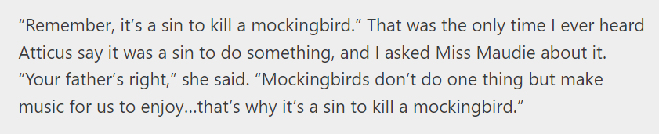
This inference helps us draw a connection between the mockingbird and Boo Radley—the mockingbird is innocent and does nothing but make music. This is a symbol of the innocence of Boo, and highlights the thematic heart of the novel: those who have the power must protect the vulnerable. It’s a beautiful inference, but you’ll note it is never stated directly in the novel. It’s a gem left to be discovered by the reader.
Inferences can help with smaller practical reading comprehension problems, too. Sometimes, if you don’t understand what a word means, you can infer its meaning from what’s around it in the sentence. Take, for example, the following sentence:

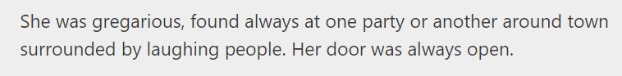

Even if you didn’t have a dictionary to tell you that gregarious means “a person who enjoys social gatherings and is fond of company,” you could glean as much from the description of the subject as someone who liked parties and whose door was “always open.”

C. Strategies for Making Inferences
You make inferences every day. Maybe you are able to finish your friend’s sentence because of the information they’ve already given you. Maybe you predict the ending of a movie before it comes. Maybe you can tell the singer is on the radio based on the sound of their voice and the topic of their song. All of these are things you’ve discovered based on surrounding facts, not actual knowledge. All of these are inferences. To get to know how to make an inference, there are several strategies that you can learn along with the exercises.
C.1 Making Inferences from Pictures
Exercise 1
Directions: Look at the picture and answer the questions. You must make inferences from the picture! Work with another student.
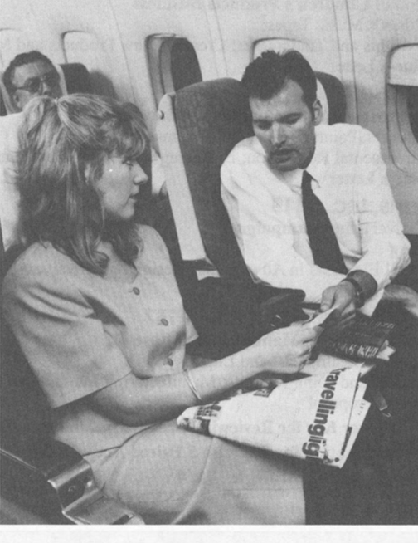
- Where are these people? _________________________________________________
- What are their jobs? _______________________________________________________________________
- What are they doing? _______________________________________________________________________
- What are they saying? ________________________________________________________________________________________________________________________________________________
Now check your answers. Talk to some other students. Do they have the same answers?
Exercise 2
Directions: Look at the picture and answer the questions. You must make inferences from the picture! Work with another student.
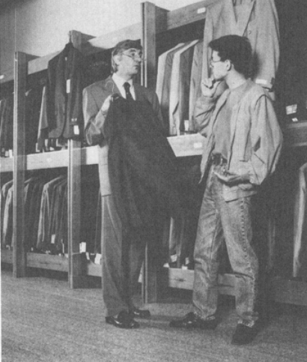
- Where are these people? Clothes store, tailor store
- What are their jobs? Customwe, buyer, salesman
- What are they doing? Bargaining, size of the suit
- What are they saying? The price is too high
Now check your answers. Talk to some other students. Do they have the same answers?
Exercise 3
Directions: Look at the picture and answer the questions. You must make inferences from the picture! Work with another student.
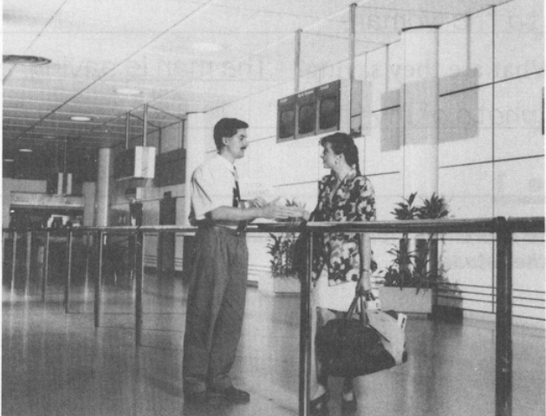
- Where are these people? At the airport, at a station
- What are their jobs?
- What are they doing? _______________________________________________________________________
- What are they saying? ________________________________________________________________________Now check your answers. Talk to some other students. Do they have the same answers?
C.2 Making Inferences from Riddles
Exercise 4
Directions: Here are some riddles about food. In riddles, you must make inferences. Can you answer the questions?

1. It’s brown.
You can drink it.
You can put milk or sugar in it.
It isn’t tea. What is it?
Coffee
2. First it’s red.
After you cook it, it’s brown.
What is it? meat

3. It’s orange.
It’s often long and thin.
Sometimes you cook it and sometimes you don’t. What is it? carrot
4. It’s white.
It’s sweet.
You can put it in coffee or tea.
You often put it in cakes. What is it? sugar
5. It’s white.
It’s not sweet.
You can put it on meat or vegetables.
You don’t put it in coffee. What is it? salt

Talk to another student. Do you have the same answers?

Exercise 5
Directions: Here are some riddles about places. Can you answer the questions?

1. It’s a building.
It’s for children.
Some adults are there, too.
The children are studying.
The adults are teaching. What is it? school
2. It’s in a building.
There are lots of tables.
Some people are eating.
Some people are cooking.
Some people are bringing food to the tables. What is it? restaurant

3. It’s not in a building.
It has trees and it sometimes has flowers.
Children like to play there.
Dogs like to run there.
People like to sit there. What is it? park

4. It’s in a building.
People sit and work there.
Other people stand and wait.
Some want to get money. Some want to give money. What is it? bank

5. It’s outside in the yard.
It’s small.
It has a door but no windows.
Something lives there.
Cats do not like to go near it. What is it? A dog house

Talk to another student. Do you have the same answers?
Exercise 6
Directions: Here are some riddles about jobs. Can you answer the questions?
1. He sees lots of children.
Some children are sick.
He helps them get well.
He listens to the mothers and fathers.
He tells them what to do. What is his job? __________________________
2. Sometimes she sits at a desk.
Sometimes she walks through the store.
She answers some people’s questions.
She helps other people at work.
She wants lots of people in the store. What is her job? __________________________
3. He works in a tall building.
His office is on top.
He has meetings in restaurants.
He makes telephone calls in his car.
He has an airplane, too. What is his job? Manager
4. She goes to different places around the world.
Sometimes there are wars. Sometimes people are dying.
She talks to the people in these places.
Then she tells their stories to the people at home.
Many people watch her in the evening. What is her job? Journalist
5. She sits down all day.
But she moves around the city.
She goes to the same places every day.
She sees many different people.
They pay to go with her. What is her job? Tour guide
Talk to another student. Do you have the same answers?
C.3 Making Inferences from the Part of a Story
Exercise 7
Directions: Make inferences from this part of the story. Read and answer the questions.
Four days later, Jenny and Blue Sky are making the beds. Suddenly they hear something. Two men are shouting. Jenny looks out of the window. She can see Jack Crane and her father in front of the farmhouse. Jack Crane’s face is very red.
“Do it!” he shouts.
“No, I’m not going to,” Sam shouts back. “It’s Sunday and I don’t work on Sundays. You do it!”
Jenny runs downstairs and out of the house. There is a strong wind and it is raining.
“What’s happening?” she asks her father.
“We’re leaving in the morning,” Sam answers. He is walking very fast. Jenny looks at him.
“But… how we are going to eat? We don’t have any money.”
Sam does not answer. His eyes are cold and hard.
1. Where are these people? Bedroom, farmhouse
2. What does Jack Crane want?
3. Why are Sam’s eyes cold and hard? He was mad at Jack
4. What does Jenny think?
Talk to another student. Do you have the same answers?
Exercise 8
Directions: Make inferences from this part of the story. Read and answer the questions.
Leaping Larry says, “We want to see the island.”
“All right,” says Duncan. “We can go in my boat.”
Duncan, Larry, and Roxanne get into Duncan’s boat. Jock jumps in, too. Roxanne is carrying Bobo.
Duncan takes them around the island. The sun is shining and it’s a beautiful day. But Roxanne isn’t happy.
“ What do you do all day?” she asks Duncan.
“Well,” says Duncan, “ I go for walks and I fish. And sometimes I go swimming.”
“Is that all?” Roxanne asks.
“Well,” says Duncan, “I’m also writing a book.”
“A book!” says Roxanne. “What about?”
“About Lana.” Says Duncan.
“Oh,” says Roxanne. “That isn’t very exciting.”
“Listen, honey,” says Larry. “We can make the island exciting. We can have pop concerts here. It’s just fine for concerts. Hundreds of people can come!”
Duncan looks at Jock. Jock looks at Duncan.
“Pop concerts!” they think. “Oh, no!”
1. Where are these people? _________________________________________________________________________
2. Where does Duncan live? _________________________________________________________________________
3. Does Larry like the island? Why or why not? _________________________________________________________________________4. What does Duncan think? _________________________________________________________________________
Talk to another student. Do you have the same answers?

C. 4 Inferring Missing Information
There are many situations in real life when you need to make inferences. Below are some exercises based on real situations. Try to use the information that is given to guess what is missing.

Exercise 9
Directions: This is a podcast from a friend. The podcast got wet, so you couldn’t read the postmark on the first line. Where has your friend gone for her vacation? Who is with her? Discuss your inferences with another student.
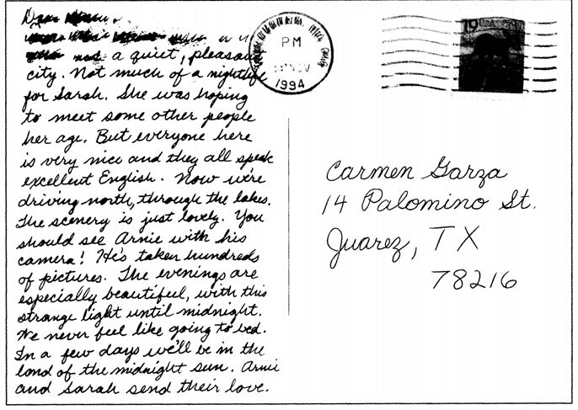
_____________________________________________________________________________________
_____________________________________________________________________________________
_____________________________________________________________________________________
_____________________________________________________________________________________
_____________________________________________________________________________________
_____________________________________________________________________________________
_____________________________________________________________________________________
_____________________________________________________________________________________
_____________________________________________________________________________________
Exercise 10
Directions: This is a notice that came into the mall. The notice was torn and some words are missing all along the edge. Who is the notice from? What is it about? Discuss your inferences with another student.
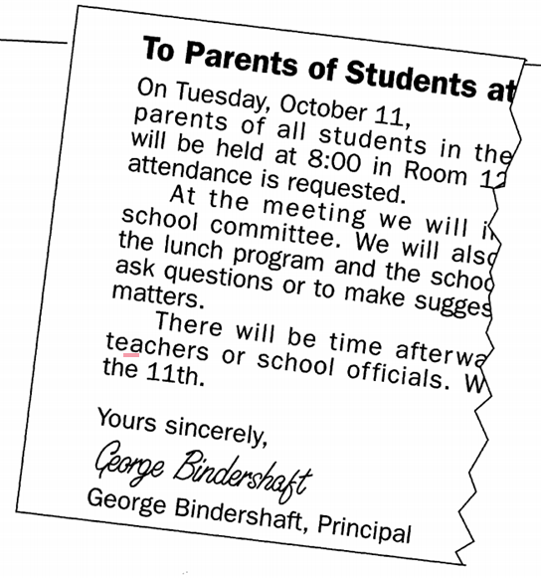
__________________________________________________________________________________________________________________________________________________________________________________________________________________________________________________________________________________________________________________________________________________________________________________________________________________________________________________________________________________________________________________________________________________________________________________________________________________________________________________________________________________________________________________________________________________________
C. 5 Making Inferences from Conversations
Have you ever overheard part of a conversation and tried to imagine what it was about? If so, you were making inferences. In the following exercises, you will practice inferring information from short dialogues. If you find words you do not know, skip over them. Look for the clues that will help you answer the inference questions.
Exercise 11
Directions: Read the conversation and try to infer the answers to the questions below
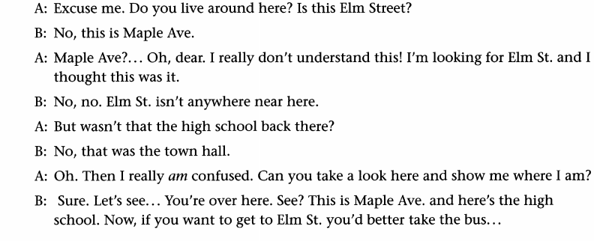
1. Who are these people? Strangers that looking for a direction
2. What are they talking about? Asking about an adress/direction
3. Are they men or women? Woman How can you tell? ‘dear’

Exercise 12
Directions: Read this conversation and infer the answers to the questions below. Discuss your inferences with another student.
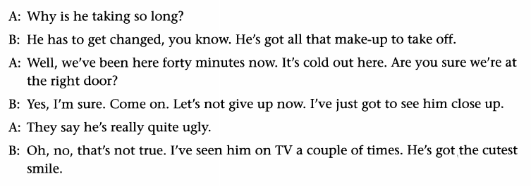
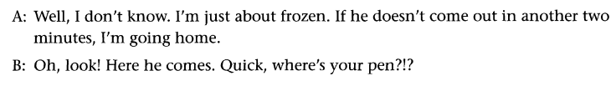
1. Where are these people?
___________________________________________________________________________
2. What are they doing?
___________________________________________________________________________
3. Who are they talking about?
___________________________________________________________________________
4. Are they men or women? How can you tell?
___________________________________________________________________________

Exercise 13
Directions: Read this conversation and infer the answers to the questions below. Discuss your inferences with another student.
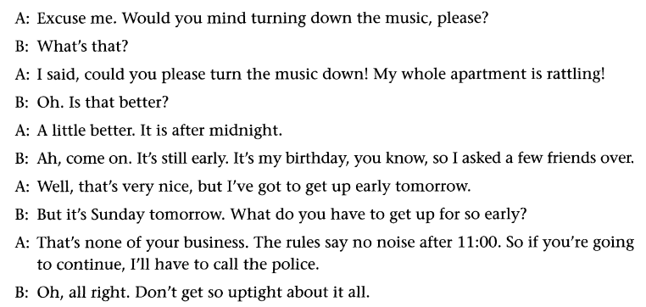
1. Where are these people?
___________________________________________________________________________
2. What are they doing?
___________________________________________________________________________
3. Who are they talking about?
___________________________________________________________________________
4. Are they men or women? How can you tell?
___________________________________________________________________________

C.6. Separating Facts from Inferences
In many kinds of writing, the author presents facts about a situation or topic and also makes inferences from those facts.
Facts are statements of information that can be verified.
For example:
1. Chile is considered one of the most conservative Catholic countries in South America.
2. On January 15, 2006, Chile selected their first woman president, the Socialist Michelle Bachelet, with 53.5 percent of their votes.
3. She is a former defense minister, a doctor, a single mother, and a non-Catholic.
Inferences are educated guesses that are based on facts.
For example:
1. People in Chile are not as conservative as generally thought.
2. People in Chile want changes in their society and economy.
3. President Bachelet’s background and experience should help her understand the problems in Chile.

Exercise 14
Directions: Preview the passage. Then read it and underline the facts. Working with another student, answer the questions that follow. The first two have been done for you.
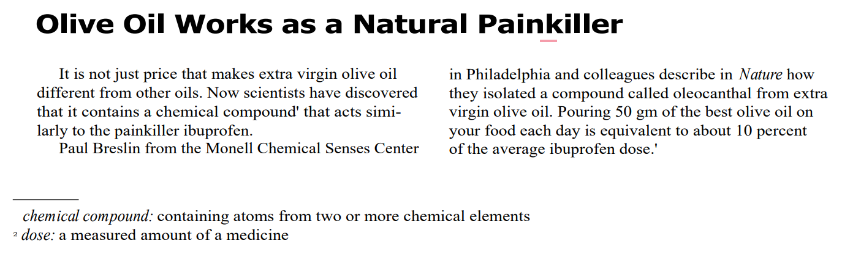
1. What facts are included in the first paragraph? Extra virgin olive oil contains a chemical compound that acts like a painkiller.
2. What can you infer about the price of extra virgin olive oil?
It costs more than other olive oils.
3. What can you infer about other kinds of oil? It’s cheaper than olive oil.
Other kinds of oil doesn’t contains a chem compound that acts like a painkiller like olive oil
4. What facts are included in the second paragraph? paul
5. What inferences can you make about Paul Breslin? Paul is a scientist for chemist
6. What can you infer about Nature? Title of journal

Compare your answers with those of another pair of students. If you disagree, explain your answers and look back at the passage to check your work.
Exercise 15
Directions: Preview the passage. Then read it and underline the facts. Working with another student, answer the questions that follow.
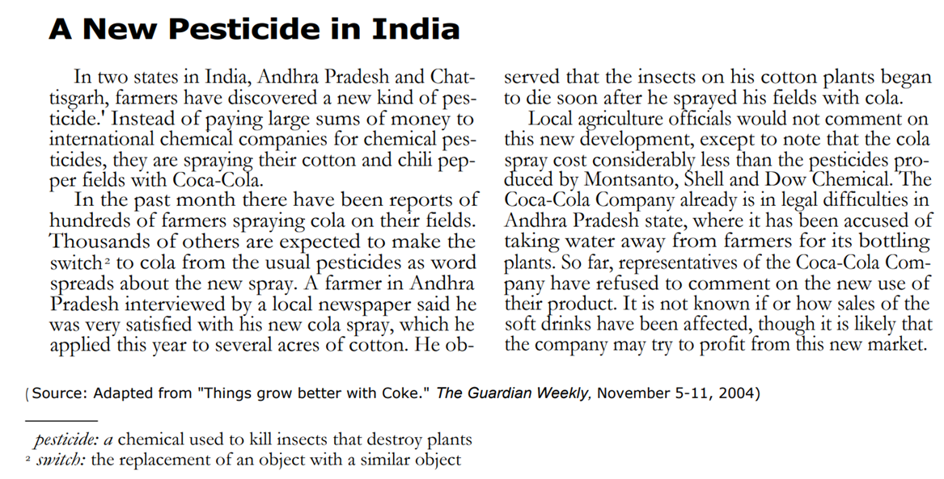
1. What facts are included in the first paragraph?
2. What can you infer about the cost of pesticides in India?

3. What facts are included in the second paragraph?
___________________________________________________________________________
4. What can you infer about cola spray?
___________________________________________________________________________

5. What facts are included in the third paragraph?
___________________________________________________________________________
6. What can you infer about the economic situation of the farmers in Andhra Pradesh?
___________________________________________________________________________
7. What can you infer about the Coca-Cola Company in India?
___________________________________________________________________________
C.7 Making Inferences from Situations
Reading can be tricky. Sometimes information is not given directly. You have to use clues to draw conclusions and inferences.
Exercise 16
Directions: In the two situations below, look for what is directly stated but can be concluded or inferred from the clues given.
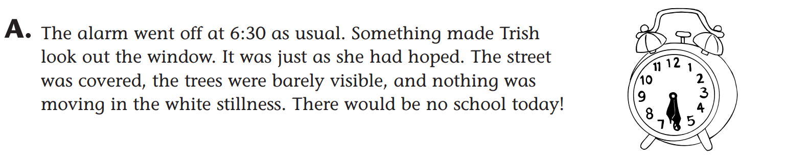

1. Was it 6:30 a.m. or 6:30 p.m.? ______________________ How do you know? __________

___________________________________________________________________________

2. What happened during the night? ______________________________________________

___________________________________________________________________________

3. What sentence gives you a clue that Trish had anticipated what happened?

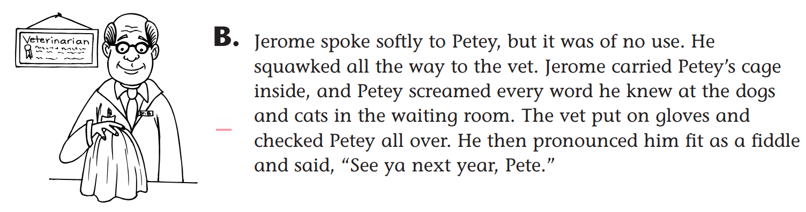

1. What specific type of pet do you think Petey is and why?

__________________________________________________________________________

__________________________________________________________________________

2. Why did the vet uses gloves when handling Petey?

__________________________________________________________________________

__________________________________________________________________________

3. Did Petey visit the vet for a routine exam or because he was injured?

_______________________________________________How do you know? ___________

__________________________________________________________________________

